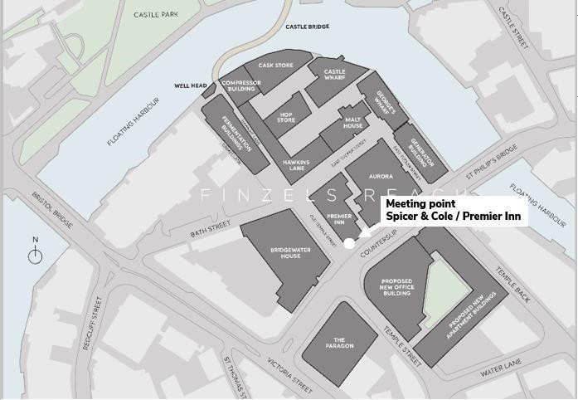

Avon Scouts – Bristol Pride Info sheet
For those that are attending Bristol Pride on the 11th July 2026

Thank you for signing up to be part of Avon Scouts’ at Bristol Pride.
I am pleased to share with you the final plans for the day. These are long, but it is important you read them in full. The Parade March is an integral part of what Pride is.

When and where
Saturday 11th July 2026. We shall meet up ahead of the parade to share with you the plans for the day and safety requirements that we need to consider before walking together to the start of the parade.

09:30 Meet-up
At Spicer & Cole / Premier Inn at Finzel’s Reach Bristol BS1 6BX (pedestrian area outside café & hotel on junction of Counterslip and Old Temple Street) for all participants.
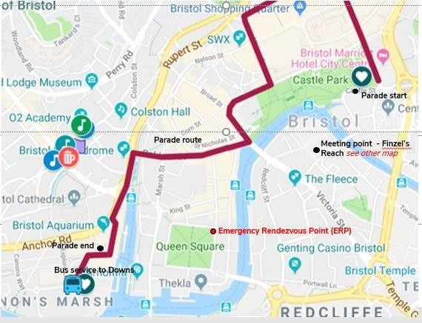

There is a coffee shop – Spicer and Cole – if you need a pre- parade hot drink, and seating outside the hotel. We will have a Rainbow Scout flag as well as our Avon Scout Pride Banner - so should be easy to spot.

Please ensure you register with Andy Scully on arrival.

09:45 Leave Finzel’s Reach, by foot, over the bridge to Castle Park (the Bandstand)
Other groups will be congregating in Castle Park, so we need to keep together and meet up at the Bandstand.
All Scouts will need to be in position in the parade by 10.15, so that we are ready to march at 10.35. We anticipate there may be some waiting until the parade moves off. We will need all scouts to help carry banners etc.

10:45 Parade starts
The parade kicks off from Castle Park, travels through town, finishing in Millennium Square. The route is about 2 miles long and will take about 1 hour to complete. There are no steps but those with limited mobility or wheelchair users may struggle with the first loop around Cabot Circus, but can join us as we pass Castle Park again at Wine Street. Given the size of the parade, it may take up to 45mins for the end of the parade to pass the start point. There will be managed road closures and counter terrorism measures are in place for safety, (see safety section below for more information).

Complete the parade 11:30 to 12.45 and make your way to the Downs (if you want to)

What to do
- Remember you will be representing Scouts and we have young people attending with us.
- Please act as you would at any other Scout event, including refraining from drinking alcohol and from smoking, and for adults, following the Yellow Card always.
- Help us show the public that Scouts is fun and welcoming, and open to all. Please interact with the crowd – smile, wave and have FUN!!!
- We will provide you with Avon Scout Pride stickers and ask that you talk to people along the way. If you see any protestors along the route, please just ignore them, don’t engage.

Social Media
Please help us raise our profile and tag any photos or comments with @avonscouts and #scoutpride

What to wear, what to bring
For the parade we ask you to wear a white shirt, branded or otherwise, and your necker. You may want to look online at Scout Store at the range of Scout Pride wear.
Face paint, glitter and rainbows are almost a ‘must’ at Pride!
Tiger Tiger have some great rainbow items (rainbow leis at just £2) and Primark are promoting biodegradable body glitter and other Pride items.
Remember we'll be standing/walking outside for at least 2-3 hours so make sure you wear

comfortable footwear such as trainers.
Be prepared for sunshine and showers, and dress accordingly, including bringing appropriate sun protection.
Ensure you bring plenty of water to keep hydrated.
You may want to bring some snacks with you as it will be a long day and there is unlikely to be access to refreshments once in the parade.

After the parade
Once the parade has finished and all equipment has been returned, everyone is free to continue with their day, please remember to stick to the pavements!

All young people must report to Andy before leaving.
Travel Logistics
Pride 2022 have arranged a dedicated quick shuttle service. Picking up from the end of the parade and this will run throughout the day to and from The Downs. First Buses 1,2,3 and 4 also run to The Downs. You can catch the bus from The Cenotaph or from College Green. What’s more with a Pride Supporter Wristband travel is FREE!

Supporter wristbands which includes discounts and a free bus travel with First Bus and a Free Shuttle Service to The Downs are available from https://bristolpride.co.uk/wristbands/
Remember if you are staying on at Pride, have fun and stay safe. If you will be drinking alcohol, going to pubs or clubbing, please remove Scout branded clothing and your Necker.

Contacts
If you have any problems on the day, you can contact:

Andy Scully | Pride Coordinator | 07748 485237
Claire Wiltshire | Alt contact | 07904 160044

Safety
Please ensue you read the emergency procedures outlined below.
- If you lose the group outside of a major emergency, call the numbers above
- If you require medical assistance or have any behaviour/ safeguarding concerns, please speak to one of the Avon Scouts team.

Major emergency procedures
- Follow all instructions provided to you by the Emergency Services and the event stewards without question and immediately.
- Remember RUN-> HIDE->TELL. The priority is your safety.
- If the group is split up, make your way to the ERP (emergency rendezvous point) when safe. This is the same as our meeting place in Queens Square.
- The ERP is not manned during the event and it will only be used in the event of a major incident. There is no need to go there under normal circumstances.

- Expect that mobile phone networks will overload and making or receiving calls may not be possible. Use text messages or internet rather than phone calls – they are more likely to get through.
- The Avon Scouts team will reach the ERP as soon as they can and stay there until 2 hours after the incident. Please do your best to either reach the ERP or contact the team within this time. If they have not heard from you after 3 hours, you will be reported missing.

